New guidance for the Password Device Setup.

**Effective immediately**: Each GARRISON will be required to insure that RecTrac/CYMS/GolfTrac users change their login password, every 90 days. GISO will need to have everyone change their passwords to meet the new DIACAP.

1. The following format has to be followed; Passwords have to be 14 characters, (10 Alpha (A-Z), 2 upper, 2 lower, 2 Numeric Characters and 2 Special Characters).

Passwords have to be changed every 90 days, with a reminder set to 10 days prior to expiration.

At least 2 Different Characters between New and Old Passwords.

Please follow screen shot below to set up a Password Device for each facility.

**Note: You will have to tell the users that the format above will have to be followed**.

1. Once you’ve created the Password Device you will need to link it in the device maintenance under the default level.
2. Once the new password device is linked at the default level the users will be forced to change their passwords when they log in.
3. Create a separate password device for the web user, you may already have a WEBPSWD devices, and link it to the www at the user level. If you do not have a WEBPSWD device, then please create one.
4. Follow the screen shots below for setup.

To create a Password Device:

File>System>Device Maintenance>Printer/Device Maintenance

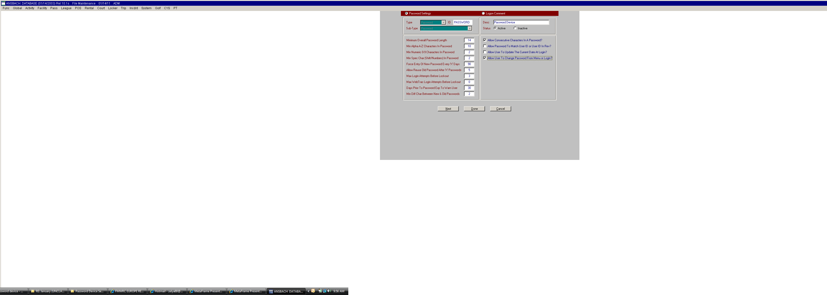

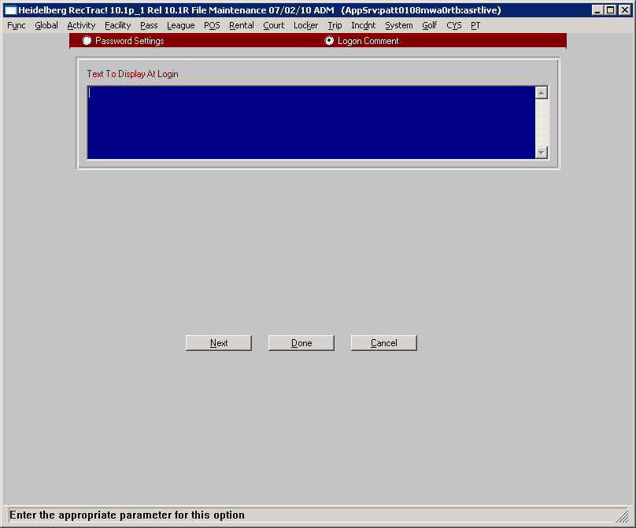

Click on **Done** to save the changes.

To Link the Password Device to the default level.

File>System>Device Maintenance>Device Assignments

Extend out the Defaults Tab>Click on Default Devices>in the Device Type select Password. In the Device to Add select the Password device you have created.

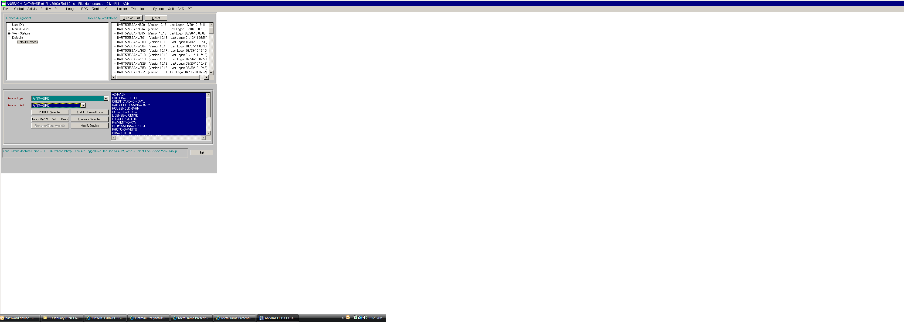

To create a WEBPSWD device:

File>System>Device Maintenance>Printer/Device Maintenance

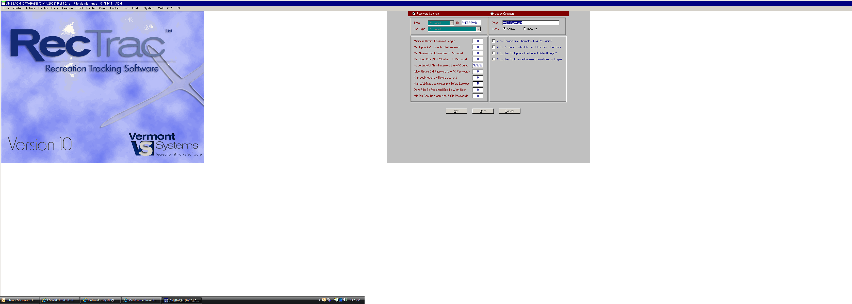

To link a WEBPSWD to the WWW user ID. *Note*: if you have more than one www user you will have to link the WEBPSWD device to each one.

File>System>Device Maintenance>Device Assignments

Extend out the User ID’s>By ID> find WWW user>in the Device Type select Password. In the Device to Add select the WEBPSWD device you have created.

